Question | Full marks | Marks (examiner) | Second marking | Comments
1 | 30
2 | 20
3 | 50
Total |  |  |  | Similarity index:
Note: This table is exclusively reserved for examiners.
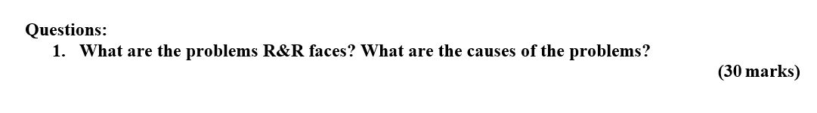
In the light of the JD-R (Job Demands-Resources) it could be highlighted that, provided work environment and culture at Raleigh & Rosse, is impacting well-being and performance of the employees (Bakker & Demerouti., 2017). The initiatives taken by the business to motivate employees for purpose of optimizing their performance has somehow settled the culture sharking and led towards many problems. Demotivated employees are not an asset for organization and R&R’s employees were demotivated due to constant pressure and job insecurity.

The major issue revolves around SPH (Sales per Hour) model introduced in order to motivate employees but due to poor controls execution of this motivational initiative did not go as per plan. The list of problems faced by Raleigh & Rosse (R&R) is as follow:

To cope up with the expansion plan of R&R, where outsiders were required to make part of mainstream management, “Ownership Culture” was introduced. As per provided case study several initiatives were taken to inculcate sense of ownership in the middle-line managers. SPH was one of those initiatives, in fact it could be considered as a hear t of the ownership culture. SPH program led towards providing hourly sale targets to the associates and there performance was started to be appraised based upon that. Any sales associate who was able to achieve the provided sales target was being rewarded with 7.3% commission of the overall sales. The actual anarchy began with the fact that any sales associate who failed to meet the provided SPH target was only paid as the basic hourly pay rate which was very low. There was a constant threat hovering over the heads of the sales associates that if they will fail to achieve their targets they could face the penalty of reduced working hours or in extreme cases they could face the termination. Job insecurity was demotivating the employees. With the framework of JD-R, Job insecurity is the biggest hindrance. Employees of R&R got their emotional well-being damaged due to constant job insecurity and increased accountability.

Another major flaw that resulted in problem was the “Hour Counting System”. At R&R to execute sale was not the only responsibility of an associate. They have to perform all other related tasks including re-stocking (to drive to other stores and fetch the required stock), attending meetings and facilitate the process of merchandizing. These non-selling hours was becoming the cause of system manipulation i.e. if these hours were counted in SPH it led towards increased sales target and if these hours were not included it led towards reduced basic pay of the associates (it majorly impacted them in the times of low sales or reduced customer foot count). This system was backfiring in either of the cases i.e. including the non-sales hours or not including the non-sales hours. This new culture brought harsh consequences for the employees. In the light of the theory of self-determination it could underpinned that every employee needs to be in full control of his or her performance, but SPH system was manipulating the work hours of employees and the employees were not able to control it as it was a systematic fault.

The recession of 2008-2009 was a period when SPH system crashed fully, it was asserted that this system was not designed taking the period of low sales in account. During the times of recession sales of luxury goods dropped by 14% in the US. Post- recession, luxury industry started to revive, R&R yet faced the decline in sales. SPH led R&R to face litigations too as during recession employees were for not meeting SPH targets (these cases were filed against the business under Federal Fair Labor Standards Act (FLSA). This was a class action lawsuit bases upon the fact that the business is violating the wage laws o hour laws. This decreased the goodwill of the business among the people leading towards decreased sales.

Work environment decides the performance of the employees, and the competition at R&R was not healthy. Associates were struggling with finances due to manipulative wage model and it created a rift between employees. They started snatching each other’s sales credit to complete their SPH targets. Not only this but these associates were always in a contest to win incentives like dinner and other prizes. This entire situation deprived the employees off a soul to work as a team and work for company’s objective; rather they were struggling to meet their individual targets. This performance pressure led the employees towards behaving unethically; they started “Sharking” against each other in order to prevent themselves from reduced pay or termination.

Despite the fact that the employees of R&R was facing “Extra Fatigue” but they were not being paid satisfactory amounts or justified incentives to recognize their efforts. The company’s slogan “Own your business, own your customer”, made the life of these associates difficult. The sales associates were engaging themselves in the activities like calling past customers, sending handwritten greetings to the customers, making deliveries to the clients, getting the clothes altered for clients etc. ; they were performing all of these activities post their working hours and this was impacting their work-life balance.

It could be assessed through the provided case study of R&R that SPH model was a failure, it demotivated employees and played role in decreasing the goodwill of the business among the people. R&R was started to be known as a brand, where employees were underpaid. The culture of R&R was proven to be toxic for the employees.
(Word count: 914)

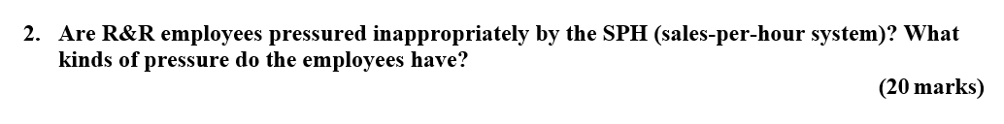
Yes! The employees at R&R were facing inappropriate pressure due to the introduction of SPH system. It was damaging their wellbeing due to the rapidly changing organizational culture; where employee penalization increased and the overall compensation decreased for most of the employees. These employees were striving to keep their job secure and not lose their commission by spending extra hours at work. Due to the inappropriate pressure these employees were performing the additional duties that were not the part of their JD; associates were transporting the purchased luxury goods to the houses of customers, was getting alterations done for the customers from the outside tailors if there were size issues with the purchased luxury dresses, were posting handwritten cards to the customers to build relationship with them and calling the past clients to ensure the repeat customers. Work-life balance is very important for the emotional and physical wellbeing of the employees; but at R&R employees were deprived of their mental piece and were in constant performance pressure.

These all efforts made by the employees were not being compensated by the employer and it was making the situation worst. Beyond any doubt SPH was a failure as it led the human resources to face undue pressure, job insecurity and induced tug-of-war among the employees. The major flaw of SPH system was that it encouraged the employees to put extra efforts and work overtime but the failed to compensate their efforts both in monetary and non-monetary terms.SPH system created a culture where even bad behavior or unethical actions were not penalized if the customer is satisfied. The time employees were spending other than performing sales i.e. in the activities like attending meetings, merchandizing or managing the stock, they were penalized for that in terms of decreased pay.

Here theory of self-determination could be underpinned (Deci & Ryan, 2013, Van den Broeck et al, 2016).It could be said that the extrinsic motivators like, achieving the SPH target for getting paid appropriately and keeping the job secure , were depriving the employees off the self-determination. The employee behavior at work was totally being controlled by the extrinsic rewards or threat of losing the reward. It deprived the employees of their autonomy to work. Employees of R&R due to SPH system were not in control of their own behavior, this system was putting undue pressure on them. This unlimited and undue pressure was leading these employees towards getting involved in unethical activities i.e. snatching the sales credit of others to fulfill their own targets.

In the light of theory of self-determination it could also be observed that there were no positive triggers were available for the employees at R&R. The theory of self-determination suggests that positive feedback and encouragement have positive impact on the employee performance. At R&R due to SPH system essence of positivity was missing, as rather than being encouraged for the additional efforts the employees were being penalized. Beyond any doubt the SPH system was that approach that did not match the contemporary theories of managing human resources and motivating them for optimizing their performance.
(Word count: 514)

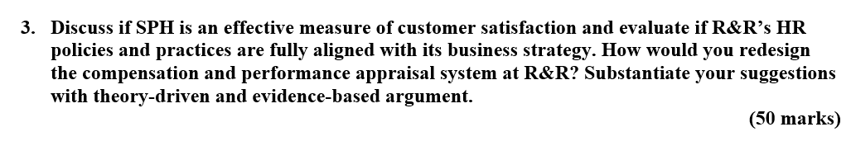
Indeed! SPH as per provided case study led initially towards forming an excellent customer base. Employees/ associates were putting extra efforts in order to achieve customer satisfaction to get better reviews as well as close more sales. The intense work environment at R&R pushed employees to go extra mile for obtaining client’s satisfaction; these employees put their all energy in enhancing customer experience. These customers were receiving hand written greeting cards from the associates, they were able to get their purchased products delivered to their door-step by the associates, they were able to save their time to get the clothes purchased for R&R altered as the associates were also helping them to get attires altered from the outside tailors etc. along with receiving all due service. These efforts not only helped R&R to achieve ultimate client satisfaction but also played role in increasing the number of clients. Later SPH system due to its unlimited consequences also resulted in employee dissatisfaction. As the lawsuits were filed against R&R under Federal Fair Labor Standards Act (FLSA), it impaired the brand’s reputation among the clients. The goodwill of the brand got damaged and ultimately it resulted in decreased number of clients; the clients were concerned about the unethical and unlawful actions of R&R.

As far as the alignment of policies with the business strategy is concerned; R&R seemed to be at the right path. The ownership culture program was introduced by Rosse in 1992 with an objective to create entrepreneurial and accountable environment. According to this perspective owners of the business wanted to enhance the employee performance by virtue of increased accountability. Introduction of SPH system was part of that strategy; R&R tried to revamp their compensation and sales-commission system by introducing SPH. SPH system was fully aligned with the business strategy of increased employee accountability as hourly performances of employees were being measured. The employees were not only being made accountable for low sales per hour but also were being penalized. They were paying penalties for poor performance in terms of getting deprived of sales commission and even job termination in the extreme cases. R&R as per provided case study was never focused upon employee motivation; they were fully focused upon JD-R model (Bakker & Demerouti., 2017). This business strategy of the R&R was not considerate of the contemporary theories of HRM i.e. theory of self-determination and A-M-O (Ability-Motivation-Opportunity) model. Though sales managers were provided staffing autonomy but associates lost their self-determination due to the low appreciation and increased pressure to earn monetary rewards or lose commission/ Job.

The compensation system at R&R was not satisfactory as it was based upon JD-R model i.e. the employees were being underpaid and they were in undue pressure to secure their commission and job (Bakker & Demerouti, 2007). JD-R model advocates, pushing employees to their limits for achieving organizational objectives (Bakker & Demerouti., 2017). The prevailing compensation system led the business into litigation for not following FLSA guidelines of minimum wage. It was contributing in demotivating the employees and putting constant pressure on them. The employees were not being compensated for the hours which they were spending upon any other work related activity than sales. As per provided case study job demands are very high but the compensation is not in accordance with that. So the first initiative that is required to be taken in regards of improving the compensation model of R&R is that, the self-determination should be taken in account, as self-determination plays vital role in employee motivation (Deci & Ryan, 2013, Van den Broeck et al, 2016).

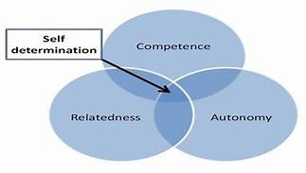

The compensation is needed to be designed in accordance with contemporary HRM concept i.e. A-M-O theory.
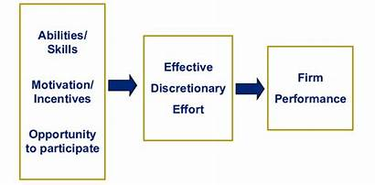
In the light of the AMO theory in the employee-employer relationship, inputs and outs are required to be in same proportion (Van Waeyenberg & Decramer, 2018). In other words employees must be compensated properly in accordance with their efforts otherwise it demotivates the employees. In the new compensation system in the light of the AMO theory, non-selling hours are needed to be paid appropriately (Van Waeyenberg & Decramer, 2018). The improved compensation plan must include the clear differences and paying schedule of selling and non-selling hours. Following is the list of the measures new compensation plan in accordance with AMO theory, is required to include for making it satisfactory.
- The compensation must be designed in accordance with the laws of state, and FLSA should not be ignored. Underpaying employees is demotivating them and impairing their performance. It is also damaging the goodwill of the brand among the customers.
- The new compensation plan must differentiate clearly between the selling and non-selling hours. SPH should be calculated only upon selling hours and non-selling hours must also be paid according to the decided wage rate. The total wage of an employee should be separated in two categories i.e. non selling hours at the rate of basic wage and selling hours in accordance with SPH.
- Overtime of the employees must be recognized in monetary terms, that basic hourly wage should also be awarded to employees on every extra hour spent at work.
- To make employees secure about their job and provide them with stable income in the new compensation plan, commission is also needed to be revised. The salary must include 70% basic pay and 30% commission earned.
- Employees must get commission upon every sale, for raising the bar high, slab system must be introduced. For example on 10 sales a day commission would be offered at 5% per sale but at the 11th sale the commission slab will change to 7% per sales.
- Annual bonus plans are needed to be implemented; these bonuses are not be awarded only at the sales but overall performance and the efforts of these associates.

Employee appraisal systems are of great significance to the employees and to the organization as well. If the appraisal systems are used appropriately these help to motivate the employees and enhance their performance (Appelbaum et al, 2000). The appraisal system is also required to be considerate of the self-determination model. Employees are needed to be appraised not only based upon the customer feedback but their efforts they are making. Every individual’s contribution on the job is needed to recognize in the appraisal system. Promotions and bonuses should not only be provided at the sales but also the non-sales activities that are helping the business grow. Following are the points that are required to be focused upon in the new appraisal system.
- The employees must be appraised for their all positive efforts they put in order to help the business grow by sustaining clients.
- Appraisal should not focus only at sales but also at the non-sales activity.

(Word count: 1114)

References (of all in-text citations in your three questions if applicable; Harvard/APA style)
Appelbaum, E., Bailey, T., Berg, P., Kalleberg, A.L. and Bailey, T.A., 2000. Manufacturing advantage: Why high-performance work systems pay off. Cornell University Press.
Bakker, A.B. and Demerouti, E., 2007. The job demands‐resources model: State of the art. Journal of managerial psychology.
Bakker, A.B. and Demerouti, E., 2017. Job demands–resources theory: Taking stock and looking forward. Journal of occupational health psychology, 22(3), p.273.
Deci, E.L. and Ryan, R.M., 2013. Intrinsic motivation and self-determination in human behavior. Springer Science & Business Media.
Van den Broeck, A., Ferris, D.L., Chang, C.H. and Rosen, C.C., 2016. A review of self-determination theory’s basic psychological needs at work. Journal of Management, 42(5), pp.1195-1229.
Van Waeyenberg, T. and Decramer, A., 2018. Line managers’ AMO to manage employees’ performance: the route to effective and satisfying performance management. The International Journal of Human Resource Management, 29(22), pp.3093-3114.

-The End-

